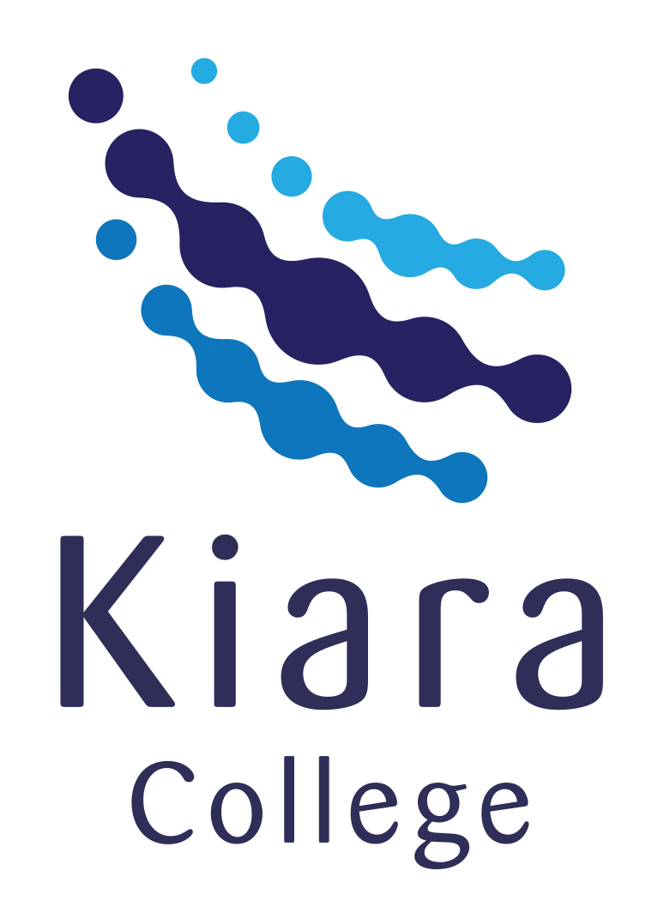
YEAR 12 CHEMISTRY – 3BCHE

SEMESTER 2

LAB THEORY TEST 2

Organic Chemistry – Experiment 25 & 26

Recommended time: 1 hour

/ 20

Name: _____________________________________________________

Teacher: _____________________________________________________



Laboratory Test: Alcohols and Esters (20 marks)

Answer the following questions based on Experiments 25 and 26

- What colour change was observed when:

(a) an aqueous solution containing acidified sodium dichromate was added to a primary alcohol? (1 mark)

from_______________________________ to ______________________________

(b) an aqueous solution containing acidified potassium permanganate was added to a secondary alcohol? (1 mark)

from_______________________________ to ______________________________

- (a) Draw the structure of the organic product formed when each of the following was treated with excess acidified
dichromate and provide IUPAC names for them. (5 marks)

Reactant | Structural formula of product (if any) | IUPAC name of product (if any)
ethanol

butan-2-ol

2-methylpropan-2-ol

- Write a balanced chemical equation for the reaction that occurred when excess potassium permanganate was added to butan-1-ol. (3 marks)

________________________________________________________________________________________________

________________________________________________________________________________________________

________________________________________________________________________________________________

(c) State one (1) observable change with this reaction. (1 mark)

________________________________________________________________________________________________

- An orange odour was produced when octan-1-ol was added to ethanoic acid in the presence of concentrated sulfuric acid.

- Draw the structure of the organic product formed. (1 mark)

- Why was sulfuric acid used in this experiment? (1 mark)

________________________________________________________________________________________________

- State the chemical formula of the non-organic product formed in this reaction. (1 mark)

________________________________________________________________________________________________
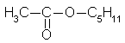
The structural formula of the ester responsible for the odour of pear is:

- Draw the structural formula of the organic reactants required to make the ester above. (2 marks)

- Provide a brief reason as to why each of the following steps was performed during the oxidation of alcohols experiments.

- H₂SO₄ was added to the Na₂Cr₂O₇ and to the KMnO₄ solutions before they were added to the alcohols. (1 mark)

________________________________________________________________________________________________

________________________________________________________________________________________________

- The alcohol and Na₂Cr₂O₇ mixtures were placed in a hot water bath for up to 5 minutes. (1 mark)

________________________________________________________________________________________________

________________________________________________________________________________________________

- The oxidation of alcohols experiment posed some quite hazardous situations that could possibly occur.
Briefly describe two possible dangerous situations and the steps taken to prevent them from happening.
(2 marks)

i. ______________________________________________________________________________________________

________________________________________________________________________________________________

ii. ______________________________________________________________________________________________

________________________________________________________________________________________________

END OF LAB TEST

